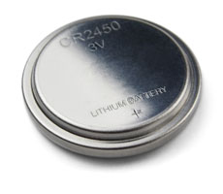
Button Battery Dangers
Button batteries are dangerous to kids, especially toddlers, and cause severe injuries when swallowed. The batteries can become lodged in the throat, burning the esophagus. In 2010 alone, more than 3,400 swallowing cases were reported in the U.S. -- 19 children sustained life-threatening or debilitating injuries and others died.
Did you know…?
- The coin-sized batteries children swallow come from many devices, most often mini remote controls. Other places you may them include singing greeting cards, watches, bathroom scales and flameless candles.
- It takes as little as two hours to cause severe burns once a coin-sized lithium battery has been swallowed.
- Once burning begins, damage can continue even after the battery is removed.
- Kids can still breathe with the coin lithium battery in their throat. It may not be obvious at first that something is wrong.
- Repairing the damage is painful and can require multiple surgeries.
Tips for battery safety:
- Search your home and any place your child goes for gadgets that may contain coin lithium batteries.
- Secure coin lithium battery-controlled devices out of sight and reach of children, and keep loose batteries locked away.
- Share this life-saving information with caregivers, friends, family members and sitters.
In case of emergency:
Keeping these batteries out of reach and secured in devices is key, but if your child swallows a battery, follow these steps:
- Go to the emergency department immediately. Tell doctors and nurses that your child may have swallowed a battery. If possible, provide the medical team with the identification number found on the battery’s package.
- Do not let the child eat or drink until a chest X-ray can determine if a battery is present.
- Do not induce vomiting.
- Call the National Battery Ingestion Hotline at 202-625-3333 for additional information.

